Digital Marketing Campaign Performance Report
Quick Overview: This report breaks down how our digital marketing campaigns performed across 8,000 customers. We cleaned the dataset, analyzed it using SQL queries, and uncovered actionable takeaways on what drives conversions.

1. Key Campaign Highlights
Here is a quick snapshot of the high-level numbers from the campaign analysis:
- Total Audience Analyzed: 8,000 customers
- Total Conversions: 7,012 successful conversions
- Overall Conversion Rate: 87.65%
- Average Ad Spend per Customer: $5,000.94
- Average Click-Through Rate (CTR): 15.48%
- Average Time Spent on Site: 7.73 minutes
2. Simple 4-Step Project Workflow
- Step 1: Data Collection – Imported raw campaign performance data containing customer metrics from Kaggle.
- Step 2: Cleaning & Formatting – Cleaned column names into clear formats, checked for zero missing values, group-binned age and income tiers, and created human-readable target labels.
- Step 3: Database & SQL Queries – Uploaded clean data to a MySQL database to extract clear business metrics without clutter.
- Step 4: Visual Dashboard – Connected the dataset to Power BI for clear, interactive visual reporting.
3. Core Takeaways from SQL Queries
3.1 Audience & Demographics
- Gender Balance: Conversion rates remain nearly identical between female (87.62%) and male (87.69%) audiences, showing equal effectiveness across genders.
- Age Group Consistency: Adults aged 32–43 yield the highest conversion rate at 87.93%, but conversion rates stay remarkably high across all age groups (87.35% to 87.93%).
- Income Tiers: High-income customers lead conversions at 88.15%, while medium (87.51%) and low-income tiers (87.29%) follow closely behind.
3.2 Marketing Channels & Campaign Types
- Top Performing Channel: Referral marketing achieved the highest conversion rate (88.31%), followed very closely by PPC (88.28%).
- Budget Efficiency (Social & Email): Social Media and Email channels operated on lower ad spend budgets while outperforming baseline conversion expectations, making them cost-effective scaling opportunities.
- Conversion-Focused Campaigns Win: Campaigns specifically optimized for 'Conversion' achieved a massive 93.36% conversion rate and the lowest cost per conversion ($5,312.06) compared to Awareness or Consideration campaigns (~85.56%).
3.3 Customer Behavior & Engagement Signals
- Site Time Matters Most: Customers who converted spent +26.5% more time on the website (7.93 min vs. 6.27 min) compared to non-converted visitors.
- Email Engagement Signals: Email clicks showed a +32.5% higher frequency among converted customers (4.61 clicks) versus non-converted (3.48 clicks).
- Past History Boosts Loyalty: Converted users averaged 4.61 previous purchases (+27.0% higher than non-converted users).
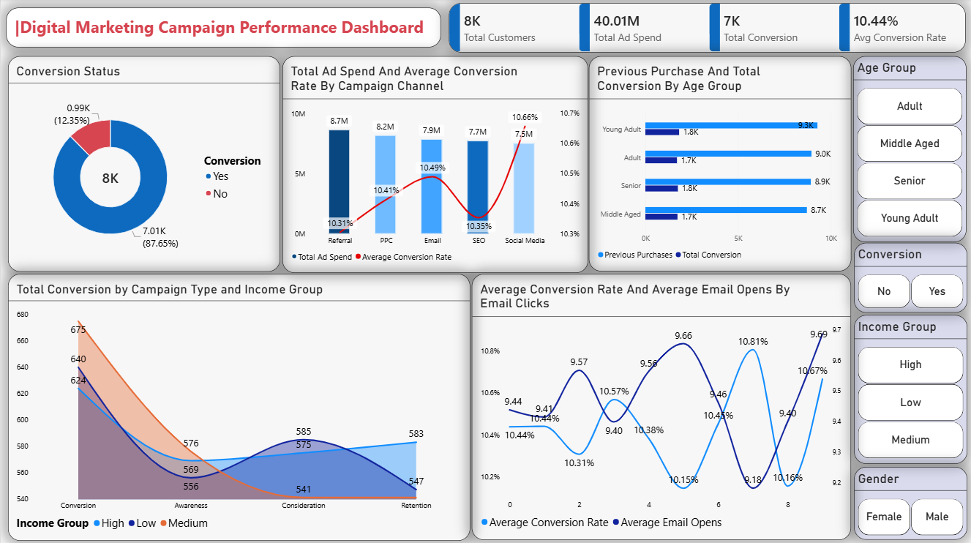

4. Key Takeaways & Recommendations
- Double Down on Conversion-Specific Campaigns: Spend more of your marketing budget on campaigns that target people who are ready to make a purchase. This brings in a much higher return on your investment and costs less.
- Scale Spend on Email & Social Media: Reallocate budget into Email and Social Media channels to take advantage of their efficiency and lower cost-per-conversion rates.
- Retarget Engaged Users: Set up automatic messages for people who have already bought from you or spent a lot of time on your website. These actions show they are highly likely to buy again.

